Roles | Name | Designation | Signature | Date
Author
Reviewer

Approver

Revision History
DCO no. | Revision | Change Description | Author | Effective Date
DCO XXXXX | 01 | Initial Release |  | XX-XXX-XXXX

- PURPOSE

  - To define an incoming inspection system to ensure that incoming raw materials, parts or finished products are inspected and/or tested for conformance to Kyron specified requirements before proceeding to the manufacturing process.
  - To define a manufacturing in-process inspection control procedure to ensure defective product do not proceed to subsequent operations.
  - To define an out-going inspection control procedure and ensure outgoing defective products are not delivered to the customer.

- SCOPE

  - Applies to incoming goods purchased for manufacturing products produced by Kyron.
  - Work in-progress semi-finished goods and final products manufactured by Kyron.

- REFERENCES

  - External Documents

ISO13485:2016

3.2 Related Documents
    - Quality Manual
    - QS-12-QA Control of Non-Conforming Product Procedure
    - QS-17-OP Identification & Traceability Procedure

- DEFINITIONS
NA

5.0 RESPONSIBILITY

QA Department shall be responsible;
- For performing inspection on specific incoming goods and ensure that the quality of all incoming goods is in accordance with the specified requirements.
- Approve or reject material/product after inspection and liaise with respective suppliers for action if required.
- Work together with Production and Supply Chain staff to ensure that defectives or faulty products do not proceed to subsequent operations.
- Authorized finished device released.

6.0 PROCEDURES

6.1 Incoming Inspection
6.1.1 Incoming goods shall receive by the respective department who shall verify the
contents of the vendor delivery order/invoice against the Purchase Order.
6.1.2 Material/products required to be inspected may assign with a unique in-house batch number in accordance to Identification and Traceability Procedure (QS-16-OP)
6.1.3 Quality Assurance (QA) Inspector shall apply Sampling Plan for conducting inspection and shall reference to respective work instruction/material specification.
6.1.4 Results of inspection shall be recorded on QA Incoming Inspection Report (FM-18001).
6.1.5 For every batch of chemical / finished device delivered, supplier shall accompany a copy of Certificate of Analysis COA or Certificate of Conformance (COC) together with the incoming goods.
6.1.6 When results of inspection do not meet required specification, Incoming Failure Report (FM-18004) will be raised and update the Incoming Failure Report Log (FM-18005). Goods will be moved to Quarantine area and affixed with ‘OUT’ red sticker.
IFR YYYY-XX
where
YYYY: Current year
XX: Running number
6.1.7 Material/Product that passed the incoming inspection shall move to identified ‘Passed’ area and affixed with ‘OK’ green sticker.

6.2 In-Process Inspection

6.2.1 Sampling inspection is carried out by QA inspector base on respective work instruction /product specification.
6.2.2 QA Inspector shall apply Sampling Plan for conducting inspection.
6.2.3 If product is found to deviate from inspection criteria, the inspected lot shall be on-hold at Quarantine area and await final disposition. Non-Conformance Report (FM-12001) may be raised.
6.2.4 Results of inspection shall be recorded on QA In-Process Inspection Report (FM-18002).

6.3 Outgoing Inspection
6.3.1 Sampling inspection is carried out by QA inspector base on packaging requirements, including contents of the labels.
6.3.2 QA Inspector shall apply Sampling Plan for conducting inspection.
6.3.3 If product is found to deviate from inspection criteria, the inspected lot shall be on-hold at Quarantine area and await final disposition. Non-Conformance Report (FM-12001) may be raised.
6.3.4 Results of inspection shall be recorded on QA Outgoing Inspection Report (FM-18003).

6.4 Finished Product Release

QA HOD or manager shall authorize product release once product has passed all testing via
Lot/Batch Release Report (FM-18006).

6.5 Pre-Shipment Inspection
Finished product is subjected to QA inspection to ensure correct products, quantity, labelling and no external damaged to the products picked by logistic staff prior shipment against customer order. Pre-Shipment Inspection Report (FM-18007) shall be maintained.

6.6 Product Status Identification
6.6.1 The identification of inspection and test status shall be maintained to ensure that only products that have passed through the required inspection and test is used and to avoid mixed-up with product without inspection or tests.
6.6.2 The recording status shall be put 'O / OK' for acceptable and for unacceptable shall be
put a 'X / OUT'.
6.6.3 Acceptable / non-acceptable product shall be physically segregated by location / area or by labels indication.

6.7 Sampling Method / Plan

Sampling method is adopted from ISO 2859-1 using single sampling plan for normal inspection (Table 2-A) comprises of various inspection level and sampling plan on different process with consideration on the risk involved, organization resources, technology, etc
Refer to Appendix 1 for Sampling Plan, Size and Inspection Table.

6.8 Inspection Records

All inspection records form part of the Device History Record (DHR) and shall be stored and maintained in accordance with the Control of Documents and Records procedure (QS-03-QA)

6.9 Reporting / Data Analysis

All data collected shall be used for monitoring, analysis, evaluate, improvement and report to management on monthly basis. Data analysis can be performance in accordance to Analysis of Data Procedure (QS-25-QA).

- RECORD

7.1 FM-18001 QA Incoming Inspection Report
7.2 FM-18002 QA In-Process Inspection Report
7.3 FM-18003 QA Outgoing Inspection Report
7.4 FM-18004 Incoming Failure Report
7.5 FM-18005 Incoming Failure Report Log
7.6 FM-18006 Lot/Batch Release Report
7.7 FM-18007 Pre-Shipment Inspection Report

- APPENDIX

Appendix 1 – Incoming Inspection Flow
Appendix 2 – In-Process Inspection Flow
Appendix 3 – Outgoing Inspection Flow
Appendix 4 - Sampling Plan, Size and Inspection Table

Appendix 1 : Incoming Inspection Flow

IFR
Certificate of Conformance and packing list
(If applicable)
Yes
Purchasing
QA sign, stamp to release material
Receipt of incoming goods
Record Batch No. & receive info to be recorded.
Incoming goods inspection
PO
Inspection
Specification
Meet
Spec.
Place in the Inventory Area
Yes
Incoming inspection?
No

Appendix 2 : In-Process Inspection Flow

Materials/
Parts
Processing
Production perform Inspection and Testing
Meet Spec
Final Product
Nonconformities
Non-Conformance

Quality Control QC

Meet Spec
NO
NO
YES
YES
Work Order/Inspection Form, as part of the DHR

Appendix 3 : Outgoing Inspection Flow

Work Order/Inspection Form as part of the DHR
Final release
Put on stock
File DHR
NCR
Final Product
No
Yes

Appendix 4: Sampling Plan, Size and Inspection Table

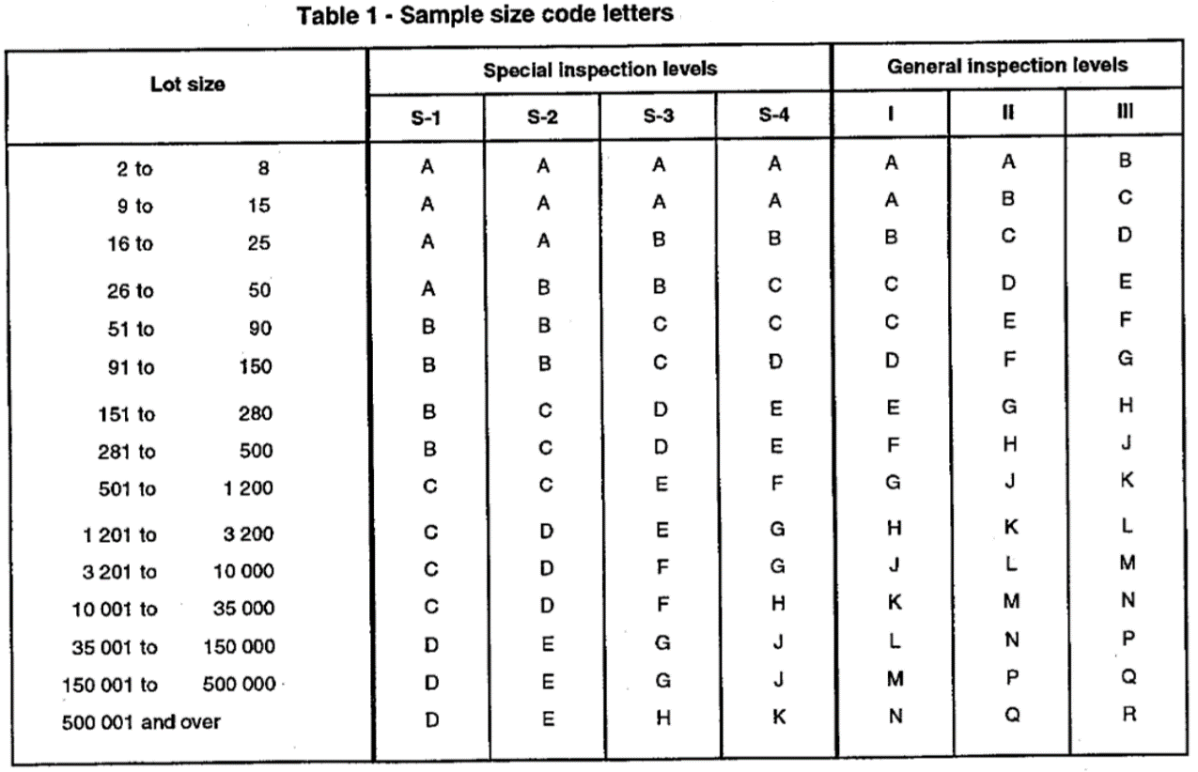

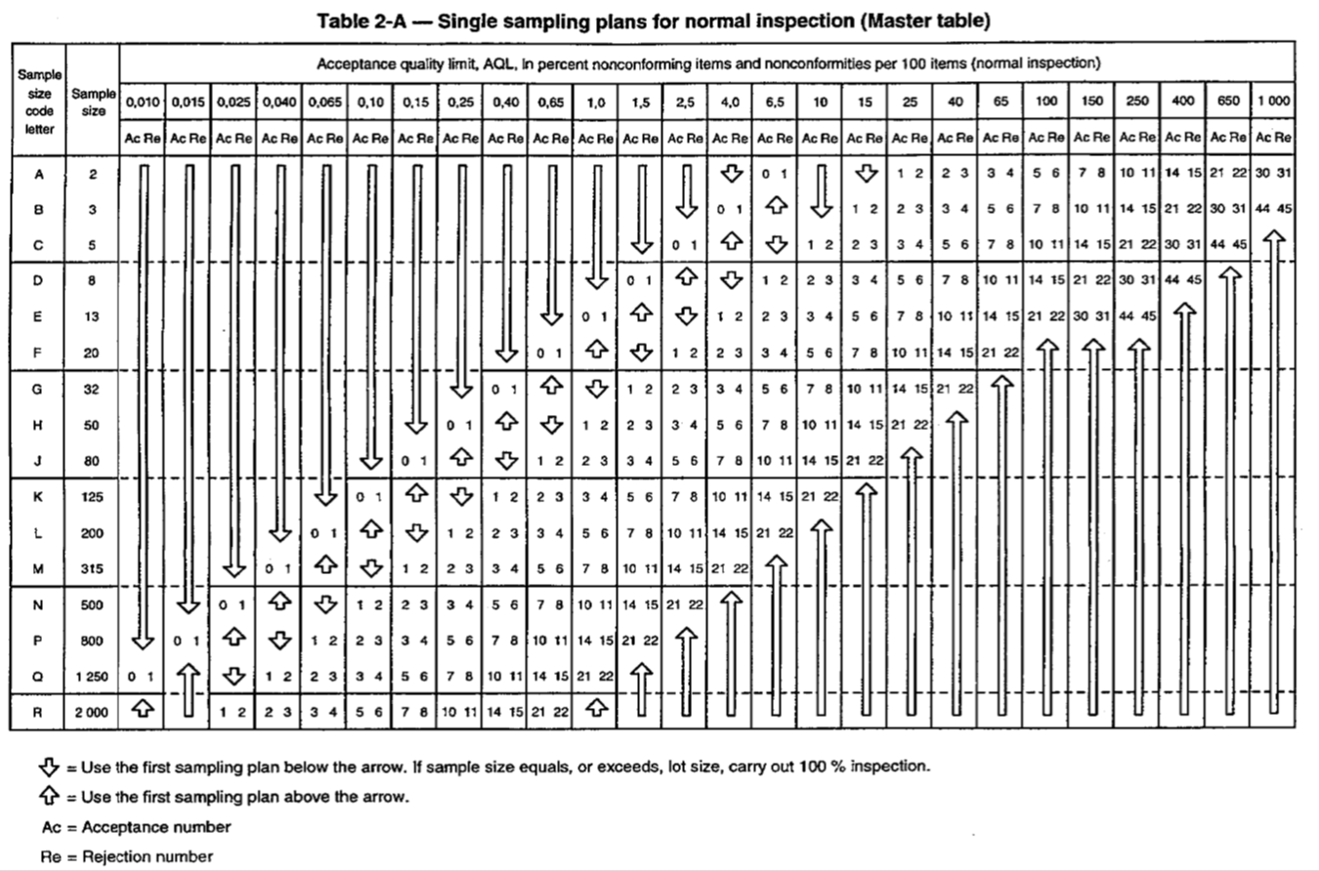

Incoming Inspection - AQL 4.0

No. | Lot / Batch Size | Inspection Level | Sample Size Code Letters | Inspection Qty. | Inspection Method | Acceptance Criteria | Accept | Reject
1 | 2 -15 | S-3 | A | 2 | WI Docs XX | Spec Docs XX | 0 | 1
2 | 16 - 50 | S-3 | B | 3 | WI Docs XX | Spec Docs XX | 0 | 1
3 | 51 - 150 | S-3 | C | 5 | WI Docs XX | Spec Docs XX | 0 | 1
4 | 151 - 500 | S-3 | D | 8 | WI Docs XX | Spec Docs XX | 1 | 2
5 | 501- 3,200 | S-3 | E | 13 | WI Docs XX | Spec Docs XX | 1 | 2
6 | 3,201 - 35,000 | S-3 | F | 20 | WI Docs XX | Spec Docs XX | 2 | 3

In-Process Inspection - AQL 4.0

No. | Lot / Batch Size | Inspection Level | Sample Size Code Letters | Inspection Qty. | Inspection Method | Acceptance Criteria | Accept | Reject
1 | 2 -15 | S-3 | A | 2 | WI Docs XX | Spec Docs XX | 0 | 1
2 | 16 - 50 | S-3 | B | 3 | WI Docs XX | Spec Docs XX | 0 | 1
3 | 51 - 150 | S-3 | C | 5 | WI Docs XX | Spec Docs XX | 0 | 1
4 | 151 - 500 | S-3 | D | 8 | WI Docs XX | Spec Docs XX | 1 | 2
5 | 501- 3,200 | S-3 | E | 13 | WI Docs XX | Spec Docs XX | 1 | 2
6 | 3,201 - 35,000 | S-3 | F | 20 | WI Docs XX | Spec Docs XX | 2 | 3

Outgoing Inspection / Pre-shipment Inspection - AQL 1.5

No. | Lot / Batch Size | Inspection Level | Sample Size Code Letters | Inspection Qty. | Inspection Method | Acceptance Criteria | Accept | Reject
1 | 2 - 50 boxes | S-4 | C | 5 | WI Docs XX | Spec Docs XX | 0 | 1
2 | 51 - 500 boxes | S-3 | D | 8 | WI Docs XX | Spec Docs XX | 0 | 1
3 | 501 - 1,200 boxes | S-3 | E | 13 | WI Docs XX | Spec Docs XX | 0 | 1
4 | 1,201 – 35,000 boxes | S-3 | F | 20 | WI Docs XX | Spec Docs XX | 1 | 2

